AI Assignment 05

- Implement the simple random restart hill-climbing algorithm with (at least) five restarts.

Simple Hill Climbing
Restart Count = 5
Start Time: 2018-12-03 19:02:01.128591
Stop Time: 2018-12-03 19:02:01.164288
Time Taken: 0:00:00.035697
Original Cost : 70922.6810091509
New Cost : 68533.0180776275

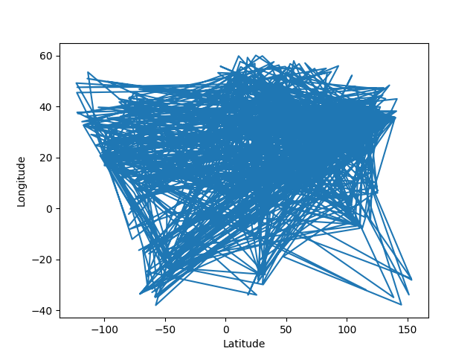
- Implement the steepest-ascent random restart hill-climbing algorithm with (at least) five restarts.

Steepest-Ascent Hill Climbing
Restart Count = 5
Start Time: 2018-12-03 18:27:21.533040
Stop Time: 2018-12-03 18:59:43.707773
Time Taken: 0:32:22.174733
Original Cost : 70922.6810091509
New Cost : 20727.99024324781

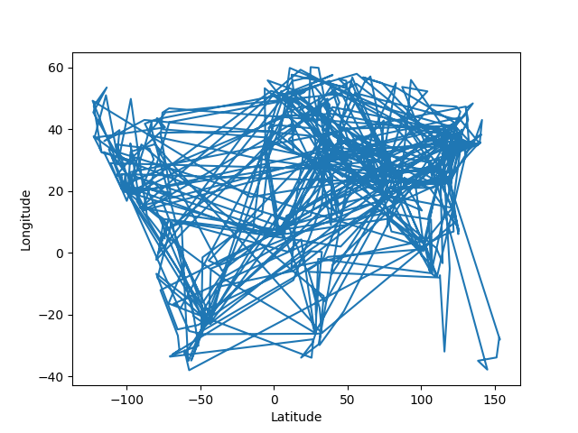
- Implement simulated annealing and report results for 1, 5 and 20 minutes.

Simulated Annealing

Time = 1 min

Start Time: 2018-12-03 20:26:38.331202
Stop Time: 2018-12-03 20:27:38.253997
Time Taken: 0:00:59.922795
Original Cost : 70922.6810091509
New Cost : 40682.201057992104

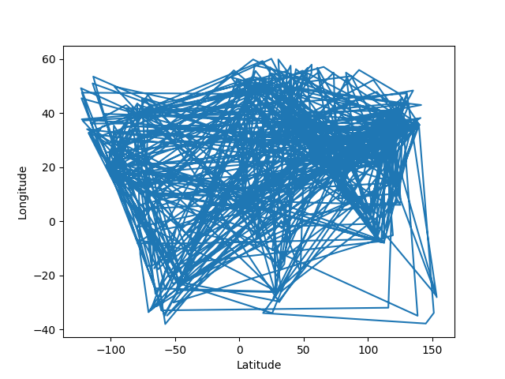
Time = 5 mins

Start Time: 2018-12-03 20:20:14.084108
Stop Time: 2018-12-03 20:25:13.685296
Time Taken: 0:04:59.601188
Original Cost : 70922.6810091509
New Cost : 37799.27209440877

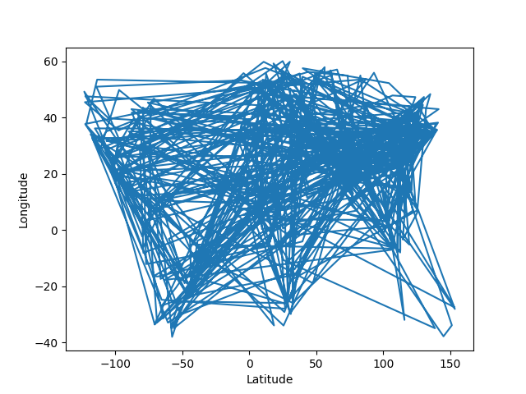
Time = 20 mins

Start Time: 2018-12-03 20:28:58.251514
Stop Time: 2018-12-03 20:48:56.644486
Time Taken: 0:19:58.392972
Original Cost : 70922.6810091509
New Cost : 33643.25269949945

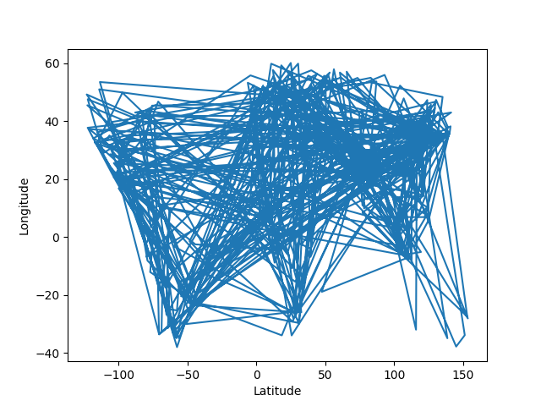

Code Execution:

In order to execute the code please run the Main.py file in Python3. Different configurations can be set using through the config.py file. The options are as follows,

filename = './Cities/cities_full.txt'
# Used only in Simple and Steepest Ascend
Restart_Count = 5
# Used only in Simulated Annealing
Time_To_Execute_Min = 1
Algorithm_Options = ['Simple Hill Climbing', 'Steepest Ascend', 'Simulated Annealing']
# Set 0 for Simple Hill Climbing
# Set 1 for Steepest Ascend Hill Climbing
# Set 2 for Simulated Annealing
Algorithm = Algorithm_Options[2]

